**EXPERIMENT NO:-1**

**AIM:**

To study various DDL commands – CREATE

**PROCEDURE:**

## Table 1: DEPOSIT

ACTNO VARCHAR(5) PRIMARY KEY, FIRST LETTER MUST START WITH ‘D’ CNAME VARCHAR(15) FOREIGN KEY REFERENCES CUSTOMER

BNAME VARCHAR(20) FOREIGN KEY REFERENCES BRANCH AMOUNT NUMBER (8,2) NOT NULL, CANNOT BE 0 ADATE DATE

**Table 2: BRANCH**

BNAME VARCHAR(20) PRIMARY KEY CITY VARCHAR(30) NOT NULL , any one of NAGPUR, DELHI, BANGALORE, BOMBAY

**Table 3: CUSTOMER**

CNAME VARCHAR(15) PRIMARY KEY CITY VARCHAR(20) NOT NULL,

## Table 4: BORROW

LOANNO VARCHAR2(8) PRIMARY KEY / FIRST LETTER MUST START WITH ‘L’ CNAME VARCHAR2(15) FOREIGN KEY REFERENCES CUSTOMER

BNAME VARCHAR2(20) FOREIGN KEY REFERENCES BRANCH AMOUNT NUMBER(8,2) NOT NULL, CANNOT BE 0

**INSERTION OF VALUES**

1. **Inserting values to Branch**

|  |  |
| --- | --- |
| VRCE | NAGPUR |
| AJNI | NAGPUR |
| KAROLBAGH | DELHI |
| CHANDNI | DELHI |
| DHARAMPETH | NAGPUR |
| MG ROAD | BANGALORE |
| ANDHERI | BOMBAY |
| NEHRU PALACE | DELHI |
| POWAI | BOMBAY |

1. **Inserting values into Customer table**

|  |  |
| --- | --- |
| ANIL | CALCUTTA |
| SUNIL | DELHI |
| MEHUL | BARODA |
| MANDAR | PATNA |
| MADHURI | NAGPUR |
| PRAMOD | NAGPUR |
| SANDIP | SURAT |
| SHIVANI | BOMBAY |
| KRANTI | BOMBAY |
| NAREN | BOMBAY |

1. **Inserting values into Deposit table**

|  |  |  |  |  |
| --- | --- | --- | --- | --- |
| Actno | Cname | Bname | Amount | Adate |
| D100 | ANIL | VRCE | 1000.00 | 1-MAR-95 |
| D101 | SUNIL | ANJNI | 500.00 | 4-JAN-96 |
| D102 | MEHUL | KAROLBAGH | 3500.00 | 17-NOV-95 |
| D104 | MADHURI | CHANDNI | 1200.00 | 17-DEC-95 |
| D105 | PRAMOD | MG ROAD | 3000.00 | 27-MAR-96 |
| D106 | SANDIP | ANDHERI | 2000.00 | 31-MAR-96 |
| D107 | SHIVANI | VIRAR | 1000.00 | 5-SEP-95 |
| D108 | KRANTI | NEHRU PLACE | 5000.00 | 2-JUL-95 |
| D109 | MINU | POWAI | 7000.00 | 10-AUG-95 |

1. **Inserting values into borrow table**

|  |  |  |  |
| --- | --- | --- | --- |
| L201 | ANIL | VRCE | 1000.00 |
| L206 | MEHUL | AJNI | 5000.00 |
| L311 | SUNIL | DHARAMPETH | 3000.00 |
| L321 | MADHURI | ANDHERI | 2000.00 |
| L371 | PRAMOD | VIRAR | 8000.00 |
| L481 | KRANTI | NEHRU PLACE | 3000.00 |

**PROGRAM CODE:-**

CREATE DATABASE BANK;

USE BANK;

CREATE TABLE BRANCH(BNAME VARCHAR(20) PRIMARY KEY,CITY VARCHAR(30) NOT NULL );

INSERT INTO BRANCH VALUES("VRCE","NAGPUR");

INSERT INTO BRANCH VALUES("AJNI","NAGPUR");

INSERT INTO BRANCH VALUES("KAROLBAGH","DELHI");

INSERT INTO BRANCH VALUES("CHANDNI","DELHI");

INSERT INTO BRANCH VALUES("DHARAMPETH","NAGPUR");

INSERT INTO BRANCH VALUES("MG ROAD","BANGALORE");

INSERT INTO BRANCH VALUES("ANDHERI","BOMBAY");

INSERT INTO BRANCH VALUES("NEHRU","PALACE DELHI");

INSERT INTO BRANCH VALUES("POWAI","BOMBAY");

SELECT * FROM BRANCH;

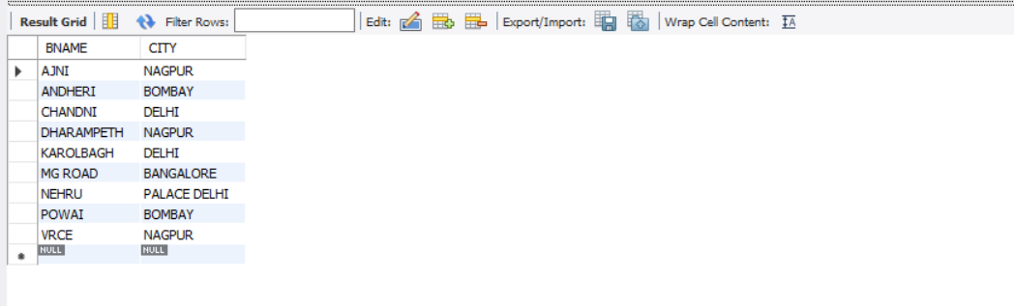

CREATE TABLE CUSTOMER(CNAME VARCHAR(15) PRIMARY KEY,CITY VARCHAR(20) NOT NULL);

INSERT INTO CUSTOMER VALUES("ANIL","CALCUTTA");

INSERT INTO CUSTOMER VALUES("SUNIL","DELHI");

INSERT INTO CUSTOMER VALUES("MEHUL","BARODA");

INSERT INTO CUSTOMER VALUES("MANDAR","PATNA");

INSERT INTO CUSTOMER VALUES("MADHURI","NAGPUR");

INSERT INTO CUSTOMER VALUES("PRAMOD","NAGPUR");

INSERT INTO CUSTOMER VALUES("SANDIP","SURAT");

INSERT INTO CUSTOMER VALUES("SHIVANI","BOMBAY");

INSERT INTO CUSTOMER VALUES("KRANTI","BOMBAY");

INSERT INTO CUSTOMER VALUES("NAREN","BOMBAY");

SELECT * FROM CUSTOMER;

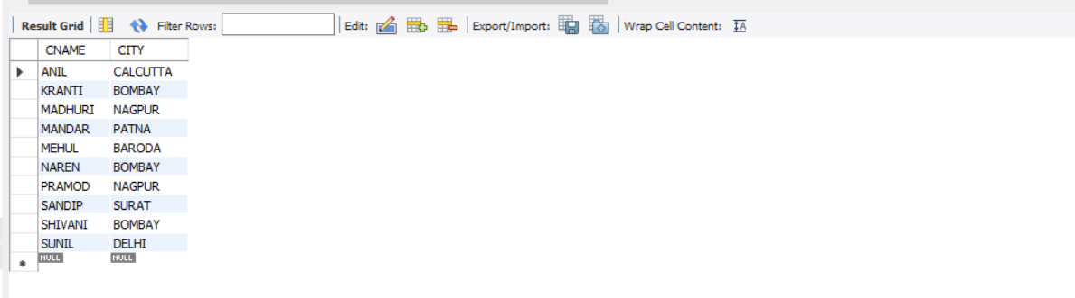

CREATE TABLE DEPOSITE(ACTNO VARCHAR(5) PRIMARY KEY CHECK(ACTNO LIKE 'D%'),CNAME VARCHAR(15), FOREIGN KEY(CNAME) REFERENCES CUSTOMER(CNAME),BNAME VARCHAR(20), FOREIGN KEY(BNAME) REFERENCES BRANCH(BNAME),AMOUNT FLOAT NOT NULL CHECK( AMOUNT!=0),ADATE DATE);

INSERT INTO DEPOSITE VALUES('D100','ANIL','VRCE',1,'1995-03-01');

INSERT INTO DEPOSITE VALUES('D101','SUNIL','AJNI',500.00,'1996-01-04');

INSERT INTO DEPOSITE VALUES('D102','MEHUL','KAROLBAGH',3500.00,'1995-11-17');

INSERT INTO DEPOSITE VALUES('D104','MADHURI','CHANDNI',1200.00,'1995-12-17');

INSERT INTO DEPOSITE VALUES('D105','PRAMOD','MG ROAD',3000.00,'1996-03-27');

INSERT INTO DEPOSITE VALUES('D106','SANDIP','ANDHERI',2000.00,'1996-03-31');

INSERT INTO DEPOSITE VALUES('D107','SHIVANI','DHARAMPETH',1000.00,'1995-09-05');

INSERT INTO DEPOSITE VALUES('D108','KRANTI','NEHRU',5000.00,'1995-07-02');

INSERT INTO DEPOSITE VALUES('D109','MANDAR','POWAI',7000.00,'1995-08-10');

SELECT * FROM DEPOSITE;

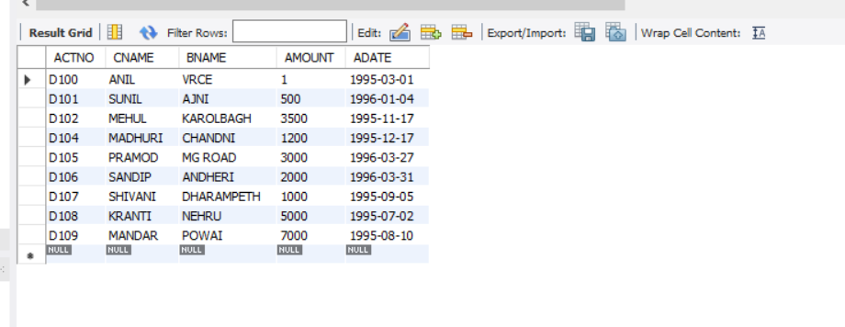

CREATE TABLE BORROW(LOANNO VARCHAR(8) PRIMARY KEY CHECK(LOANNO LIKE 'L%'),CNAME VARCHAR(15),FOREIGN KEY(CNAME) REFERENCES CUSTOMER(CNAME),BNAME VARCHAR(20),FOREIGN KEY(BNAME) REFERENCES BRANCH(BNAME),AMOUNT FLOAT NOT NULL CHECK(AMOUNT!=0));

INSERT INTO BORROW VALUES('L201','ANIL','VRCE',1000.00);

INSERT INTO BORROW VALUES('L206','MEHUL','AJNI',5000.00);

INSERT INTO BORROW VALUES('L311','SUNIL','DHARAMPETH',3000.00);

INSERT INTO BORROW VALUES('L321','MADHURI','ANDHERI',2000.00);

INSERT INTO BORROW VALUES('L371','PRAMOD','POWAI',8000.00);

INSERT INTO BORROW VALUES('L481','KRANTI','NEHRU',3000.00);

SELECT * FROM BORROW;

